.Aero domain information

Domain Name: ………………..aero

Fields marked with an asterisk (*) are required.

Organization: *.
Contact Name: *…………………………… İMZA SİRKÜSÜ YETKİLİ İSMİ GEREKLİ
Street 1: *……………….
Street 2:
Street 3:
City: *…………..
Postal Code: *……………
State/Province:……………
Country: * ……………….

Telephone
Telephone Country Code: *………..
Enter plus sign and country code.
Number: *………..
Enter 7-11 digits. Enter digits only for best results.

Ext:
Fax
Fax Country Code: *………….
Enter plus sign and country code.
Fax: *-
Enter 7-11 digits. Enter digits only for best results.
Ext:
Email: *……………
Registrant Group: *aviation education and research

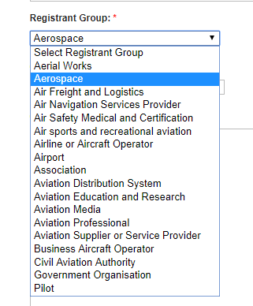

Supply the following information in Credential Value field below: URL or free text

Credential Value: *…………………
